Abstract— Public sector organizations have often been less inclined to fully explore the benefits of knowledge management than the private sector. This paper is aimed to design a Knowledge Management System (KMS) Model with emphasis on Independent National Electoral Commission (INEC).
A Knowledge Management System (KMS) Model for a Nigerian Public Organization
Madumere Smart Onyemaechi, Agada Bob Chile, Ihim Kingsley
Currently, a lot of public sector information is collected, stored and processed using documents, unrelated Information Systems, and in organization practices internalized by employees. Organizational turnover has also created challenges in the form of knowledge retention and knowledge delivery. Inadequate information access due to information storage challenges is a major problem that hampers proper knowledge service delivery at all levels within the Nigeria public sectors e.g. (INEC).To remain at the forefront, INEC also needs to have a Knowledge Management capability that will store, organize, share, utilize, create and integrate their unmatched knowledge resources, hence the developmentofa Knowledge Management System (KMS) Model is proposed. The features proposed KMS for Nigerian public service organizations will be based on, and aligned with the simplified three-layer model of [5]: 1) Infrastructure Services - storage and communication, 2) Knowledge Services – creating, sharing and reuse, 3)Presentation Services – personalization and visualization, and on the technologies relevant to these services. Structured System Analysis Design Methodology (SSADM) was employed; the results indicated that the proposed model can effectively facilitate the process of storage, sharing and application of KM in the public sectors
Index Terms— Knowledge, Knowledge Management, Public sector.

INTRODUCTION
Highlight It is certainly true that in the last decade the creation, sharing and application of knowledge are increasingly seen as a source of competitive advantage. However, knowledge management is largely a private sector innovation at the present time, although gradually moving towards the public service sector [3], [10]. The implementation of knowledge management places an emphasis on organizational factors such as learning capability, culture and leadership as well as renewed focus on the importance of information quality [2]. The ability to manage the sharing of information (and hence knowledge) effectively remains one of the most important but still least understood activities in modern organizations, no less so in public services.
Public services represent a significant economic sector in most countries and public demands on services are increasingly consumerist. This has led to escalating scrutiny of the performance of public services. Consequently, the strategic use of information and knowledge to improve service delivery and financial performance has become a key skill for managers in this sector. Partnership working represents a formal departure from the traditional compartmentalized approach to public service delivery. Often referred to as joined-up thinking, partnership working challenges existing hierarchies, encouraging the partner organizations to work together at all levels, including strategy, service planning and service delivery to enhance efficiency and improve user experience and satisfaction. For partners to work effectively together, knowledge of best practices must be shared and utilized towards the common goal of improving the overall quality of service delivery. Our research has focused on design of knowledge management model for Nigeria public organization like Independent National Electoral Commission (INEC) responsible for creating, storing, and disseminating all aspects of information, before, during, and after elections.

KNOWLEDGE MANAGEMENT SYSTEMS (KMS)

Knowledge Management System (KMS) has been defined by different scholars in diverse dimension. According to Gallupe [8], KMS is refers as a tool or technologies that support knowledge management. Abdullabi, et.al [1] extensively defined KMS as phrase used to describe the creation of knowledge repositories, improvement of knowledge access and sharing, as well as communication through collaboration, enhancing the knowledge environment and managing knowledge as an asset for an organization. In this light, KMS can be defined as tool or Information and Communication Technologies (ICTs) that can be used to store, disseminate, collaborate, identify sources of knowledge to support the generation, capture, sharing, retrieval and use of knowledge to enhance access to source of information and knowledge by individuals, organizations, and nations as a whole. Utilization of technology in knowledge management in this 21 century is of utmost importance which offers new opportunities, provides enabling environments for knowledge sharing, communication of knowledge via technology such as video conferencing, web2.0 amongst others. Technology can be used to facilitate knowledge management all through its lifecycle. According to Egbu (7), knowledge management systems or technologies which aid the implementation of KM, consist of a combination of hardware and software. Furthermore, Hardware technologies are very important for knowledge management system as they form the platform for software technologies to perform and the medium for storage and transfer of knowledge.

KNOWLEDGE MANAGEMENT TECHNOLOGIES
Knowledge Management (KM) Technology can be categorized:
- Groupware: Software that facilitates collaboration and sharing or organizational information. Such applications provide tools for threaded discussions, document sharing, organization-wide uniform email, and other collaboration-related features.
- Workflow Systems: Systems that allow the representation of processes associated with the creation, use and maintenance of organizational knowledge, such as the process to create and utilize forms and documents.
- Content Management and Document Management Systems: Software systems that automate the process of creating web content and/or documents. Roles such as editors, graphic designers, writers and producers can be explicitly modeled along with the tasks in the process and validation criteria. Commercial vendors started either to support documents or to support web content but as the internet grew these functions merged and vendors now perform both functions.
- Enterprise Portals: Software that aggregates information across the entire organization or for groups such as project teams.
- E-learning: Software that enables organizations to create customized training and education. This can include lesson plans, monitoring progress and online classes.
- Planning and Scheduling Software: Software that automates schedule creation and maintenance. The planning aspect can integrate with project management software.
- Telepresence: Software that enables individuals to have virtual “face-to-face” meetings without assembling at one location. Videoconferencing is the most obvious example.
- Semantic Technology such as Ontologies: Systems that encode meaning alongside data to give machines the ability to extract and infer information.
These categories overlap. Workflow, for example, is a significant aspect of a content or document management systems, most of which have tools for developing enterprise portals.
Proprietary knowledge management products such as Lotus Notes defined proprietary formats for email, documents, forms, etc. the internet drove most vendors to adopt internet formats. Open-source and freeware tools for the creation of blogs and wikis now enable capabilities that used to require expensive commercial tools.
Knowledge Management is driving the adoption of tools that enable organizations to work at the semantic level, as part of the Semantic Web. Some commentators have argued that after many years the Semantic Web has failed to see widespread adoption, while other commentators have argued that it has been a success.

KNOWLEDGE MANAGEMENTSYSTEMS IN THE ENTERPEISE?
Knowledge management systems enable organizations to better manage processes for capturing and applying knowledge and expertise∙ KMS support processes for acquiring, storing, distributing, and applying knowledge, as well as processes for creating new. Hence a Knowledge Management System Model is highly needed in Nigerian Public organizations, like Independent National Electoral Commission (INEC) for effective electoral processes.

A CONCEPTUAL BASIS FOR THE MODEL
According to Nonaka and Takeuchi [10], The Knowledge Creating Company, Oxford University Press), there are two categories of knowledge: tacit and explicit.
Explicit knowledge is that which “can be expressed in words and numbers and can easily be communicated and shared in the form of hard data, scientific formulae, codified procedures or universal principles”. This is also known as codified knowledge.
Tacit knowledge is difficult to articulate and it cannot be converted into words easily: this category of knowledge.” This is represented typically as individual expertise, experience, visions, or special abilities relating to work. Tacit knowledge should be harvested and converted to competitive advantage in any modern KM system.

STATEMENT OF THE PROBLEM
According to Conyers [6], there are substantive links among information access, transparency, governance, and service delivery where information acts as a lubricant to service delivery. Service delivery in the Nigerian public is hampered by among others corruption, low productivity, inefficiency, lack of transparency and accountability. Bovaird [4] suggests that for the public service, they should embrace systematic oversight of the stock, use, generation and retention of knowledge and information, with particular attention to the placement of this in executive decision-making and the incentive and reward structures of a department or agency. Service delivery by the INEC is hampered by the fact that the Agency has failed to fully collaborate with electorates, party officials, and other stakeholders in order to share information and encourage reporting on election processes.

OBJECTIVES OF THE STUDY.
To remain at the forefront, INEC also needs to have a Knowledge Management capability that will store, organize, share, utilize, create and integrate their unmatched knowledge resources; hence the development of a Knowledge Management System (KMS) Model is proposed.
Therefore, a suitable model for any Nigerian public institution, like Independent National Electoral Commission (INEC), should incorporate both categories of knowledge and also have the following as its objectives:
- Knowledge discovery,
- Knowledgeorganization,
- knowledge creation,
- Knowledge sharing,
- knowledge reuse and
- innovation
All the above objectives can only be realized, or implemented through a heavy reliance on information and communications technologies (ICT). To achieve the above-stated objectives, the proposed model will be organized into the following groups of components:
- Architectural Components, Knowledge Management System (KMS)Architecture - KMS Architecture consists of four layers: Infrastructure layer, technology layer, protocol layer and repository layer. Each layer is a client that links to the system and can access the knowledge repositories through infrastructure layer (internet, intranet and extranet) provided.
- Feature Components – components that make up the features. Finally, based on the foregoing, the Final Model is presented

METHOD
. There is a need to apply a formal systems methodology in carrying out the system development in this research. The author follows the Structured Systems Analysis and Design Method (SSADM) with prototyping model as the main guide for development in this research. The Research methodology defined here is based on the methods, techniques, and tools used to capture and collect analysis data from a variety of information sources

FEATURE COMPONENTS OF THEKONWLEDGE MANAGEMENT SYSTEM.
The features proposed KMS for Nigerian public service organizations will be based on, and aligned with the simplified three-layer model [5].
Infrastructure Services – storage and communication
Knowledge Services – creating, sharing and reuse,
Presentation Services – personalization and visualization, and on the technologies relevant to these services.
- Infrastructure Services
This layer consists of two services – storage services and communications services. Here, each of these infrastructural services is taken up in turns.
- Storage Service:
Storage is enabled by technology as knowledge repositories. These repositories serve to house knowledge units. Each knowledge unit – usually existing as data or documents – is characterized by its content and its structure. Furthermore, the proposed model here accommodates the modern trend of including unstructured filessuch as multimedia - video, audio and graphics in the repositories
The processes of knowledge creation and knowledge reuse depend mainly on Knowledge storage services. An organization like Independent National
Electoral Commission (INEC) could implement its knowledge repository as either a Data Warehouse, or a Knowledge Server, orboth. But the Knowledge Server option is preferred in this model, as shown in Figure 1 above.
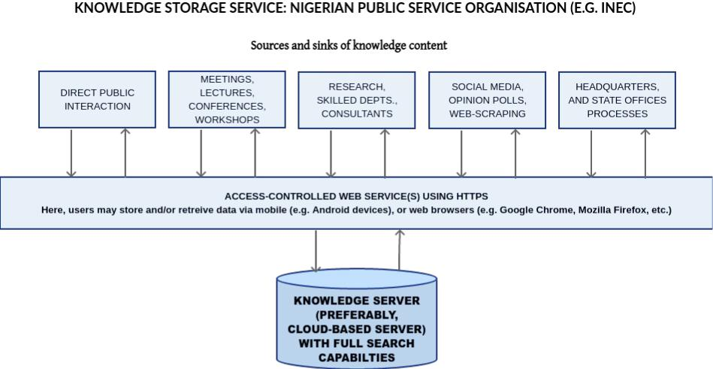

Figure 1 knowledge storage service: Nigerian public service organization (e.g, INEC)
Source: Developed by the researchers
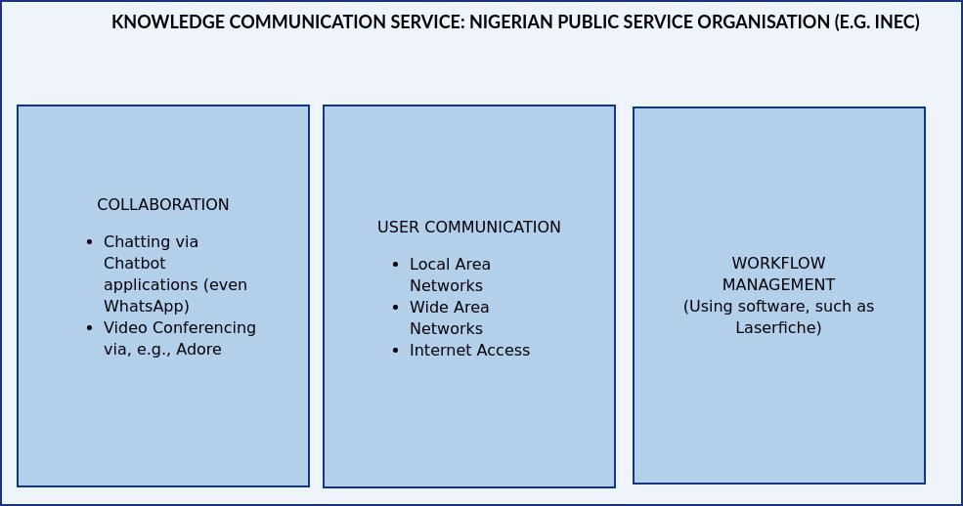

Figure 2: Communications Service. Source: Developed by the researchers
- CommunicationsService:
These services pertain to the technological enablement of user processes: collaboration, user-communication, and workflow management
- Collaboration:
Chatbotapplication and other specialized video conferencing and/or webinar applications can be developed (or otherwise acquired) to enable users (staff, consultants, etc.) to collaborate in knowledge management.
- User Communication:
Users can communicate with each other via secure emails and file sharing. ICT systems that enable such communication are local area networks (LANs), wide area networks (WANs) and sometimes secure Internet access.
- Workflow Management:
Regarding workflow management, specialized software is available that enable accelerated review, routing (and re-routing) and approval of electronic documents (proposals, memoranda, minutes of meetings, policy documents, receipts and vouchers, publicitydocuments, etc.) all done online, and without physically moving documents about. A graphic view of communication services is displayed in Figure 2 above..
- Knowledge Services
Knowledge services are technologies for creating, sharing, and reusing knowledge. The proposed model breaks these services into their component parts:
- Knowledge Creation Service:
Knowledge creation consists of three components: exploitation, exploration and codification.

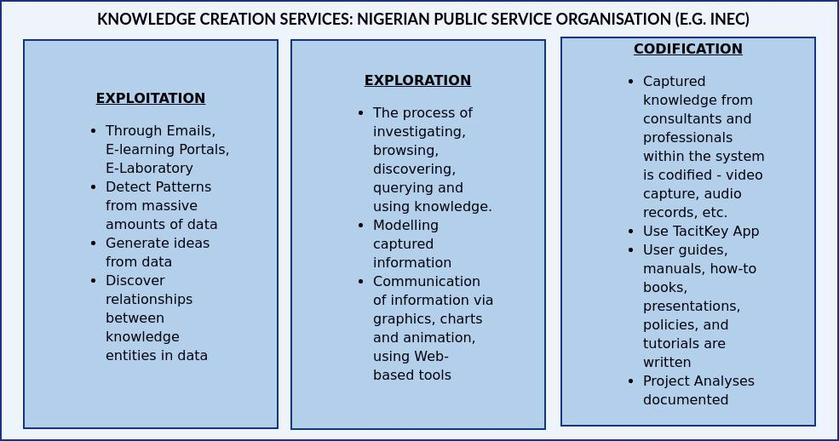
Figure 3: Knowledge creation service. Source: Developed by the researchers
For the proposed model, Figure 3summarizes the concepts of, and recommended technologies for enabling knowledge creation.
Knowledge Sharing Service:
The Sharing service in this model is shown in Figure 4. It includest wo components: networkanalysis tools and collaboration tools

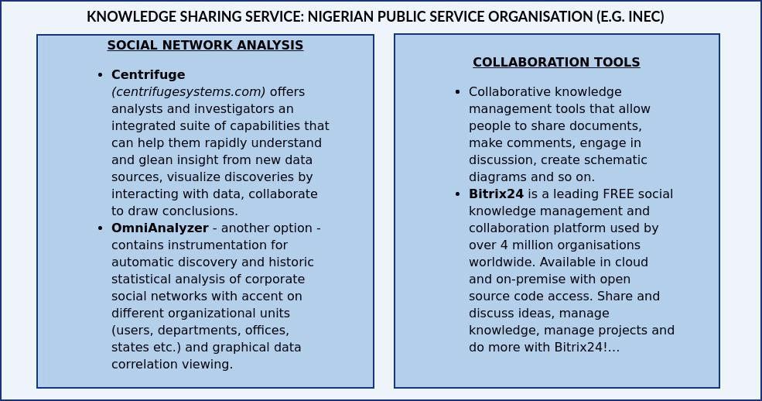
Figure 4: Knowledge sharing service. Source: Developed by the researchers
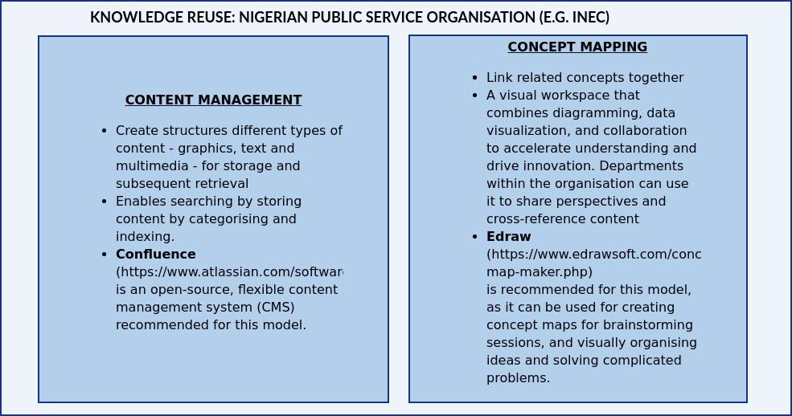
Figure 5: Knowledge reuse.
Source: Developed by the researchers

Knowledge Reuse Service:
Two technologies, namely content management and concept mapping are specifically developed for knowledge reuse. An important feature of these technologies must include powerful search capabilities. Figure 5 shows the components and recommended software for this model.
- PresentationServices
These services address the need for an enhanced interface between users of the system and the information or knowledge presented to them in order to avoid the information overload, as described earlier. The services themselves have two main features: Personalization and Visualization, both of which have been briefly described earlier.
- Personalisation Service:
Personalization - the concept of crafting a customized experience77based on context and user behavior - has long been the talk of the retail industry. But for the public sector, leaders are just starting to realize its potential - from giving constituents greater access to the information they need to speeding up and streamlining government processes.
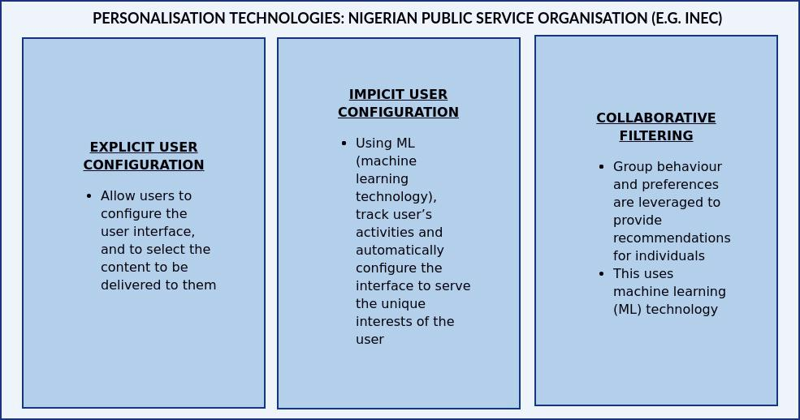
Figure 6: Personalisation technologies. Source: Developed by the researchers
Here, content available to the given user is based on the user’s profile: a user profile is a set of attribute-value pairs about the user.
Also, based on the set of attributes and values, there are rules that match content with attributes: this set of rules is sometimes referred to as the business contex. There are three main features common in personalization technologies: collaborative filtering, implicit, explicit user configuration.
Personalization software provides customization functionalities for tailoring a service or content to accommodate specific individuals or segments of individuals. These and the recommended technology for this model are presented in Figure 6

- Visualization Service:
This feature enables the user, through web-based browsing and navigation, to better understand the knowledge content. Of the various methods for implementing the visualisation feature, the proposed model will employ only the Graphical Interface implementation. In this implementation, the major themes in the content are extracted from massive amounts of unstructured text from a variety of data sources.

Recommended Technology:
R is an open-source statistical programming language that produces excellent, publication-quality graphics. There are numerous versions and add-ons available by searching online, since anyone can take R and make their own changes. It is also surprisingly easy to learn. See www.r-project.org/for the R Project site which provides a wide variety of information about R.

THE FINAL MODEL

The model brings together all the described in the forgoing components sections, and it is presented graphically in Figure 7. As earlier specified, this model is based on the simplified three-layer architecture (Chua 2009).

In the model presented in Figure 7, each layer is differentiated with a different background colour. It is recommended for the implementers of this model to proceed as follows:

Progressively from the layers, Infrastructure Services, to the Knowledge Services, and then to the Presentation Services.
At each layer, pay a close attention to the recommended technologies (hardware and software) in the model

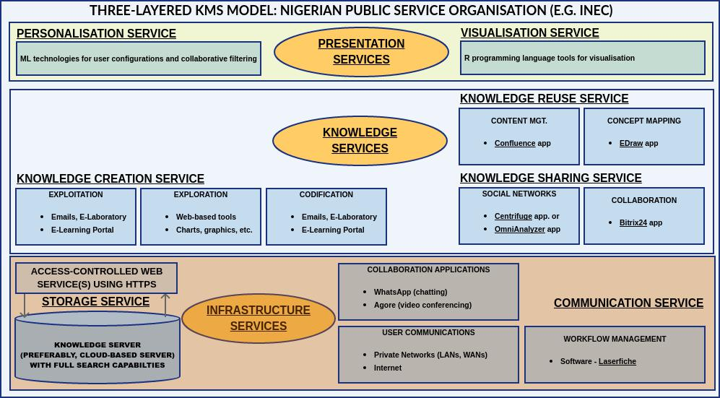

Figure 7: The final KMS model for a Nigerian public organization

ACKNOWLEDGMENT
The authors express their special thanks of gratitude to their wives , more especially Blessed Madumere as well as her little baby, MichelleMadumere who gave us the golden opportunity to do this wonderful write-up on the topic (A Knowledge Management System Model for a Nigerian Public Organization), which also helped in doing a lot of Research .

References
- Abdullabi, R., Salemat,M.H.,Sahibudin, S.H. & Alias, R.A. (2005). A Framework for Knowledge Management System implementation in collaborative environment for higher learning institutions.Journal of Knowledge Management Practice.http://www.tlainc.com/article83.html
- M. Alavi, and Leidner, D.E. (2001), "Review: Knowledge Management and Knowledge Management Systems: Conceptual Foundations and Research Issues", MIS Quarterly,25(1): 107-136, 2001.
- Bate, P. and Robert, G. (2002). Knowledge management and communities of practice in the private sector: lessons for modernizing the National Health Service in England and Wales. Public Administration, 80, 643– 663.
- Bovaird, T., Loffler, E. (2009), Public Management and Governance, Second edition, Routledge, Taylor & Francis Group, London;
- Chua, A., and Lam, W. (2005) 'Why KM projects fail: a multi-case analysis', Journal of Knowledge Management
- Conyers, D. (2007). ‘Decentralization and Service Delivery: lessons from Sub- Saharan Africa. IDS Bulletin 38 (1)
- Egbu, C. 0. &Botterill, K. 2002. Information Technologies for Knowledge Management: Their Usage and Effectiveness. ITcon, Vol. 7 pp125-135.
- Gallyupe, R.B (2000) “Knowledge Management Systems: Surveying the landscape
- Hartley, J. and Allison, M. (2002). Good, better, best? Inter‐organizational learning in a network of local authorities. Public Management Review, 4, 101– 118.
- I. Nonaka, and H. Takeuchi (1995). The knowledge-creating company. New York, NY: Oxford University Press.

 Madumere, Smart Onyemaechi, Department Of Computer Science, Alvan Ikoku Federal College Of Education, Owerri, Imo State, Nigeria Agada Bob Chile, Department Of Computer Science Alvan Ikoku Federal College Of Education, Owerri Imo State, Nigeria Ihim Kingsley, Department Of Computer Science. Alvan Ikoku Federal College Of Education, Owerri, Imo State, Nigeria I extend my special thanks to Dr. Chiedozie Ifeanyi, for his financial support

